Topic 6: Further Mechanics

0.6 Specification notice:
In order to develop their practical skills, students should be encouraged to carry out a range of practical experiments related to this topic. Possible experiments include investigating the effect of mass, velocity and radius of orbit on centripetal force.
Mathematical skills that could be developed in this topic include translating between degrees and radians and using trigonometric functions (such as tan𝚹=sin𝚹/cos𝚹).
This topic may be studied using applications that relate to mechanics, for example, transportation.

6.Q Exam questions

6.97 Understand how to use the equation impulse = F∆t =∆p (Newton’s second law of motion)

What is impulse and how is it calculated and what are its units | F∆t =∆p  - Force times the time the force acts is equal to the change in momentum  - Ns or Kgms-1  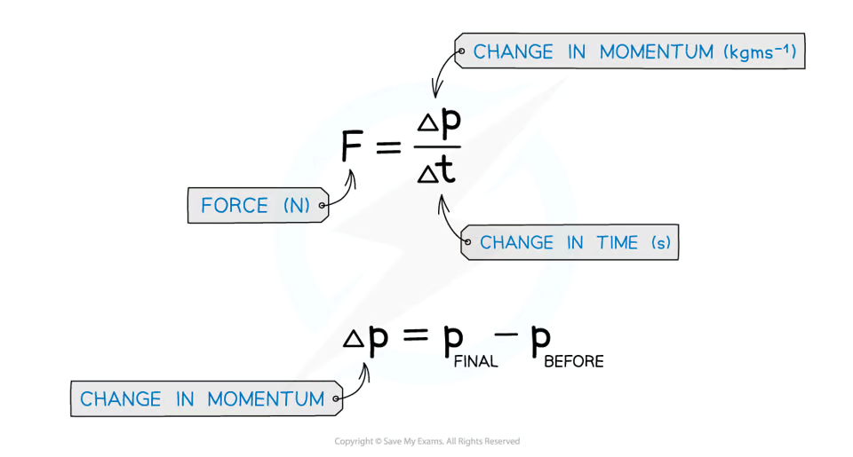  Remember that if an object changes direction, then this must be reflected by the change in sign of the velocity. As long as the magnitude is correct, the final sign for the impulse doesn’t matter as long as it is consistent with which way you have considered positive and negative  E.g if left is taken as positive and therefore right as negative, an impulse of 20Ns to the right equals to -20Ns

6.98 CORE PRACTICAL 9: Investigate the relationship between the force exerted on an object and its change of momentum.

6.99 Understand how to apply conservation of linear momentum to problems in two dimensions
What is the principle of conservation of momentum? | Total momentum before collision equals the total momentum after the collision unless an external force acts  External forces include friction. They affect the total momentum as they can reduce the velocity of an object

6.100 CORE PRACTICAL 10: Use ICT to analyse collisions between small spheres, e.g. ball bearings on a table top.

6.101 understand how to determine whether a collision is elastic or inelastic
What happens in elastic, inelastic, and perfectly inelastic collisions? | - Elastic is when both momentum and kinetic energy is conserved  - Inelastic is when momentum is conserved yet kinetic energy is not  - Perfectly inelastic is where the colliding objects stick

6.102 be able to derive and use the equation E_{k} = p²/2m for the kinetic energy of a non-relativistic particle
Derive the equation for the E_{K} of a non-relativistic particle? | - $E_{k}=\frac{1}{2}mv^{2}$  - p = mv  - Rearrange & substitute $v=\frac{p}{m}$  - $E_{k}=\frac{1}{2}m({\frac{p}{m})}^{2}$  - $E_{k}=\frac{1}{2}\frac{p^{2}}{m}$  - $E_{k}=\frac{p^{2}}{2m}$  Tip: For this type of question be aware of converting from joules to eV by dividing by 1.6x10⁻¹⁹

6.103 be able to express angular displacement in radians and in degrees, and convert between these units
How is a radian calculated, what is it defined as, and how can it be converted to degrees?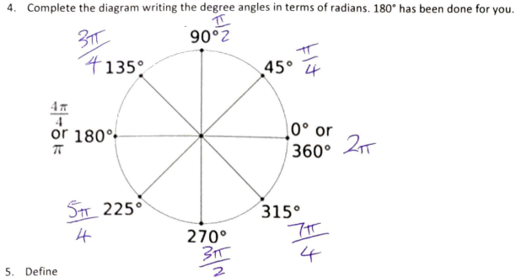 | - Dividing the arc length by the radius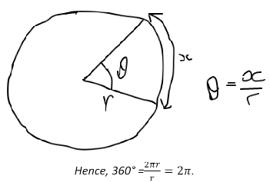  - Thus, one radian (when x =r) is defined as “the angle subtended at the centre of the circle by an arc equal in length to the radius”.  - Since 360 = 2pi, 1 = 360/2pi. To convert from radians to degrees, multiply by this
Define angular displacement and what is its equation? | - A vector measurement of the angle through which something has turned (in radians)  - rΘ = s  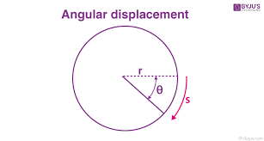

6.104 understand what is meant by angular velocity and be able to use the equations v =ωr and T=2π/ω
Define angular velocity/angular speed and what is its equation | Angular velocity:  The rate at which angular displacement is changing as an object turns through an arc (rad/s)  Angular speed:  The angle (Θ, measured in radians) an objects moves through divided by the time taken to move through that angle.  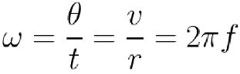
What are the equation for linear speed | v=⍵r, v=
What are the 4 equations linked to angular velocity/ angular speed | - ⍵=Θ/t <- the angular velocity/speed at a specific length on an arc  - ⍵=2π/T <- the angular velocity/speed around the whole circle  - T=1/f <- the time period/frequency of a full circle  - ⍵=2πf <- the angular frequency  Finally, you may come across ⍵ being labelled as ‘angular frequency’ because of its relationship to linear frequency f as given by the alternative equation ⍵ = 2πf. Remember the units of ⍵ are rads⁻¹, whereas the units of f are Hz

6.105 be able to use vector diagrams to derive the equations for centripetal acceleration a = v²/r = ω²r and understand how to use these equations
Define centripetal acceleration (instantaneous acceleration) ? | The change in velocity of an object on a circular path directed towards the centre of the circle at a constant speed (a = v²/r)
Derive the equation for centripetal acceleration by considering two points on a circular orbit?  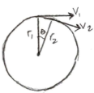 | 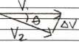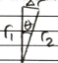  - Assume Θ is very small (as sinΘ = Θ in radians for small angle approximations) then V₁=V₂=V  - Therefore Θ = ΔV/V and Θ = Δr/r  - So ΔV/V = Δr/r  - Therefore ΔV/V = vt/r as, v=d/t=Δr/t  - Therefore ΔV/t = v²/r as a=ΔV/t  - Therefore a = v²/r  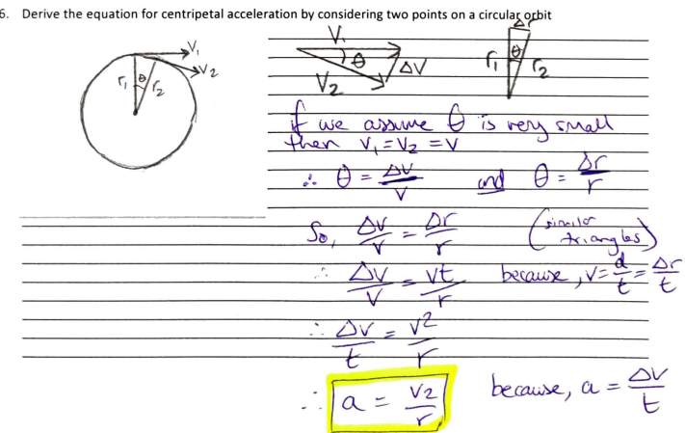
What are 3 equations for centripetal acceleration? | - a = v²/r  - a = ω²r  - a = vω  As v = ωr

6.106 understand that a resultant force (centripetal force) is required to produce and maintain circular motion
What is centripetal force and what would happen without it? | - The resultant force acting towards the centre of a circle providing a CONSTANT acceleration. (e.g., weight, friction, gravity, tension)  Since it’s not a force itself, it should never be drawn on a free body diagram.  Without it, by N_{1st} the object would fly off tangentially.
Does centripetal force act in the same direction to centripetal acceleration and why? | - Yes they both act towards the centre of the circle due to N_{2nd} law of F=ma

6.107 be able to use the equations for centripetal force F = ma = mv²/r = mrω²
What are the 4 equations for centripetal force? | - F=ma  - F=mv²/r  - F=mω²r  - F=mvω
How does tension vary for at different points along a circle with a centripetal?   | - Tmax = mv²/r + mg <- At the bottom  - Tmin = mv²/r - mg <- At the top  - T = mg <- At the left or right side  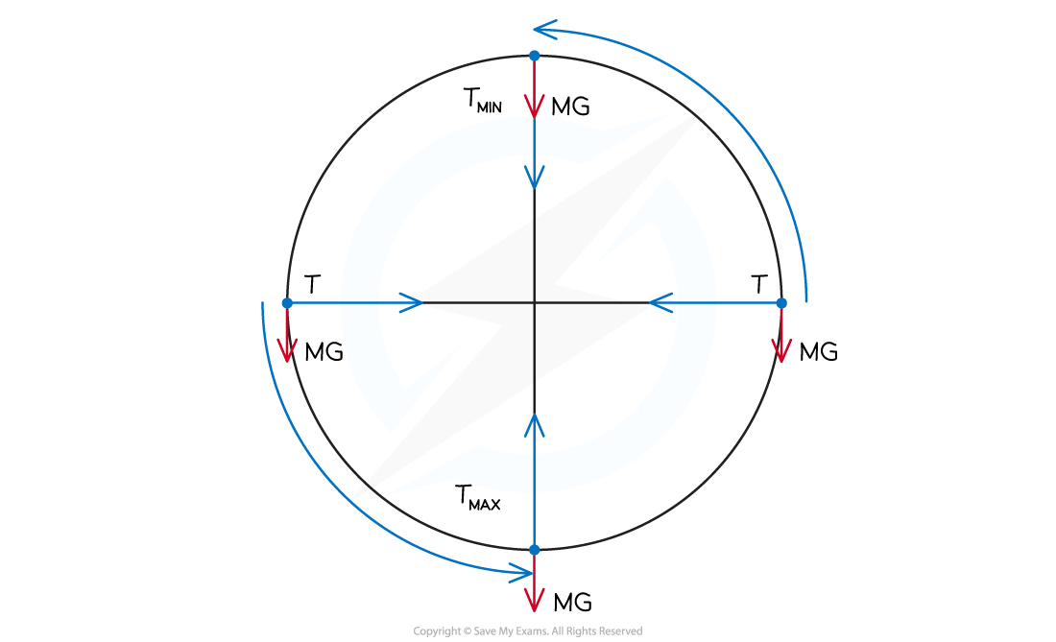
What would you use to find the velocity of a coaster in a roller coaster? | - As the coaster acceleration changes through its motion you cannot use SUVAT  - So then you would use the energy of the coaster its GPE and KE to find the velocity or minimum velocity for the coaster to stay along the circle with the centripetal  - 1mv2=mgh, v=gh  - Mgh=PE (initial) = [1/2mv2=KE + mgh=PE at top of the circle ]

